|  |  |
| --- | --- |
| Logo AGES | |
| Western grape rootworm | |
|  |  |
| 31.03.2025 02:00 Uhr | |

**Western
grape
rootworm**

**Bromius
obscurus**

Last
change:
04.09.2023

**Profile**

The
vine
drop
weevil
is
also
called
"scribe"
because
of
the
damage
symptoms
it
causes.
It
is
an
occasional
pest
of
grapevines
that
can
cause
feeding
damage
to
aboveground
plant
parts
and
the
roots.

**Appearance**

The
leaf
beetle,
5-6
mm
in
size,
is
brownish-black
in
color
and
not
shiny
metallic.
The
elytra
are
broader
than
the
cervical
shield
and
have
distinct
shoulders,
by
which
the
beetles
are
easily
recognized.

The
root-dwelling
whitish
larvae
with
brown
head
capsule
have
three
pairs
of
legs
and
grow
to
about
5
mm.

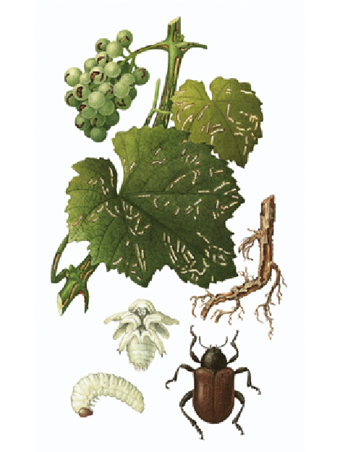

Oben:
Charakteristische
Fraßspuren
des
"Schreibers"
an
Traube
und
Rebtrieb;
Mitte
links:
Puppenstadium;
Unten
rechts:
Erwachsener
Rebenfallkäfer

**Biology**

The
vine
drop
weevil
belongs
to
the
leaf
beetle
family
(Chrysomelidae).

The
beetles
live
on
the
vines
from
the
beginning
of
May
to
August.
When
disturbed,
they
drop
to
the
ground
("vine
drop
beetle").
After
a
maturing
feeding
period
of
about
two
weeks,
the
females
lay
eggs
in
groups
of
15-20
in
cracks
in
the
old
bark
or
on
roots
near
the
surface.
After
ten
to
twelve
days,
the
young
larvae
hatch
and
feed
on
the
roots.
They
initially
destroy
the
fine
roots
and
later
feed
on
older
roots
in
spiral
tunnels.
Root
feeding
continues
into
the
fall,
or
it
continues
during
mild
winters.
Towards
the
end
of
winter,
pupation
occurs
just
below
the
soil
surface.
After
about
three
weeks
of
pupal
dormancy,
the
beetles
hatch
in
spring.

**Damage
symptoms**

The
leaf
beetles
cause
feeding
marks
on
above-ground
plant
parts
such
as
leaves,
shoots
and
berries,
which
are
about
1
mm
wide
and
10
mm
long
and
resemble
writing
characters.
Therefore,
the
vine
drop
weevil
is
also
called
"scribe".
From
midsummer,
the
berries
may
also
be
gnawed.
Symptoms
are
similar
to
those
of
"Oidium
seed
break"
caused
by
powdery
mildew.
Secondary
fungal
infections
may
additionally
damage
the
gnawed
berries.

The
larvae
feed
on
the
roots
of
the
vines.
This
causes
line
disorders,
which
can
lead
from
stunted
growth
to
the
death
of
the
canes.

**Host
plants**

In
addition
to
grapevines*(Vitis*),
evening
primrose
plants
such
as
narrow-leaved
willowherb*(Epilobium
angustifolium*)
are
also
considered
host
plants
of
the
vine
drop
weevil.

**Distribution**

The
vine
drop
weevil
is
common
in
Europe,
North
Africa,
North
and
Central
America.

**Prevention
and
control**

* Natural
  enemies
  of
  the
  vine
  drop
  weevil
  include
  insectivorous
  vertebrates
  but
  also
  ants
  that
  eat
  the
  eggs.
* Plant
  protection
  measures
  to
  control
  these
  leaf
  beetles
  are
  usually
  not
  necessary.
* Often,
  grapevine
  leaf
  beetles
  are
  included
  with
  plant
  protection
  measures
  against
  other
  pests.

**Services**

[Plant
Health
Services](en/plant/plant-health/plant-health-information)