|  |  |
| --- | --- |
| Logo AGES | |
| Spindle ermine | |
|  |  |
| 30.01.2025 18:16 Uhr | |

**Spindle
ermine**

**Yponomeuta
cagnagella**

Last
change:
17.01.2022

**Profile**

The
spindle
tree
moth
belongs
to
the
small
butterflies
and
feeds
on
the
common
spindle
bush.
The
caterpillars
form
a
web
by
which
an
infestation
can
be
easily
recognized,
as
often
the
entire
shrub
is
spun
in.

**Appearance**

The
yellow-green
caterpillars
have
two
dark
spots
on
each
body
segment
and
grow
to
about
20
mm
in
length.

The
adults
are
white
colored
moths
and
measure
25
mm
in
wingspan,
their
forewings
are
covered
with
numerous
small
black
dots.

The
eggs
are
shield-shaped
and
about
0.4
mm
in
diameter.
They
are
laid
in
groups.
Thereby
the
eggs
overlap
like
roof
tiles.

**Biology**

The
spider
moth
belongs
to
the
family
of
moths
called
Yponomeutidae.
The
gypsy
moths
are
a
group
of
small
butterflies,
which
all
look
extremely
similar.
They
differ
only
in
the
host
plants
they
attack:
for
example,
each
has
its
own
species
on
spindle
tree,
blackthorn,
weeping
cherry
or
apple
trees.

Spider
moths
overwinter
in
the
egg
stage.
Individual
eggs
are
laid
in
groups
on
smaller
twigs.
In
March/April,
small
caterpillars
hatch
from
them
and
feed
around
fresh
shoots.
In
doing
so,
they
create
a
common
web
in
which
they
live
protected
from
enemies.
In
total,
the
caterpillars
go
through
five
larval
stages.
Then
they
begin
to
spin
a
cocoon
in
which
they
pupate.
These
cocoons
often
lie
close
together
in
the
common
"webs
nest".
From
these
hatch
moths
in
June
and
July,
which
mate.
After
about
ten
days
of
egg
maturation,
they
proceed
to
lay
their
eggs
for
the
next
year.

**Damage
symptoms**

Initially,
only
individual
shoot
tips
are
spidered,
but
with
heavy
infestation,
entire
plants
appear
as
if
enveloped
in
a
fine
net.
This
can
also
result
in
complete
balding.
Masses
of
caterpillars
can
be
found
in
the
webs.

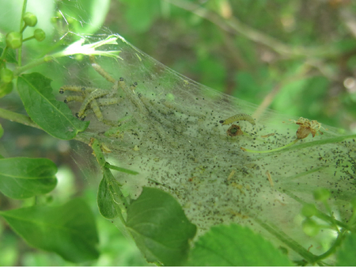

Raupen
der
Gespinstmotte
an
einem
Spindelstrauch

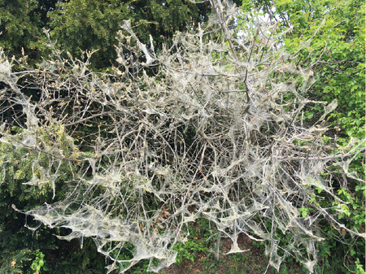

Ein
stark
befallener
Strauch

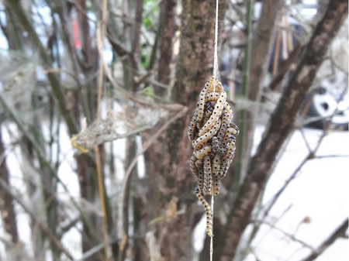

Raupen
der
Gespinstmotte
beim
Abseilen
aus
ihrem
Gespinst

**Host
plants**

The
most
important
host
plant
for
the
peacock
spider
moth
is
the
common
spindle
bush*(Euyonimus
europaeus*),
also
called
peacock.
It
has
also
been
observed
on
*E.
japonicus*
.

**Distribution**

The
peacock
spider
moth
is
widespread
in
Europe.

**Economic
importance**

The
economic
importance
of
the
spider
moth
is
negligible.
It
produces
only
one
generation
per
year,
so
that
the
damage
caused
is
usually
limited.
The
host
plants
usually
recover
very
well
after
infestation
by
the
caterpillars
and
sprout
again.
Species
that
infest
fruit
trees
(e.g.
apple
webworm
moth)
may
cause
yield
losses.

**Prevention
and
control**

* Destroy
  caterpillar
  nests
  with
  sharp
  water
  jet
* Cut
  away
  caterpillar
  nests
* Encourage
  natural
  counterparts:
  Birds,
  parasites,
  e.g.,
  various
  species
  of
  caterpillar
  flies,
  etc.
* Use
  of
  a
  plant
  protection
  product:
  For
  home
  gardens,
  products
  based
  on
  the
  bacterium
  *Bacillus
  thuringiensis*
  or
  the
  natural
  substances
  azadirachtin
  or
  pyrethrum
  are
  suitable
  (see
  [list
  of
  plant
  protection
  products
  approved
  in
  Austria](https://www.baes.gv.at/zulassung/pflanzenschutzmittel/pflanzenschutzmittelregister/)).

**Services**

[Plant
Health
Services](en/plant/plant-health/plant-health-information)