|  |  |
| --- | --- |
| Logo AGES | |
| Soybean downy mildew | |
|  |  |
| 18.04.2025 05:22 Uhr | |

**Soybean
downy
mildew**

**Peronospora
manshurica**

Last
change:
23.11.2021

**Profile**

Downy
mildew
of
soybean
is
caused
by
the
pathogen
*Peronospora
manshurica*.
Downy
mildew
fungi
(Peronosporaceae)
belong
to
the
class
of
egg
fungi,
which
are
also
known
as
oomycetes.
Drippable
water,
such
as
dew,
is
essential
for
the
life
cycle
of
egg
fungi.

**Damage
symptoms**

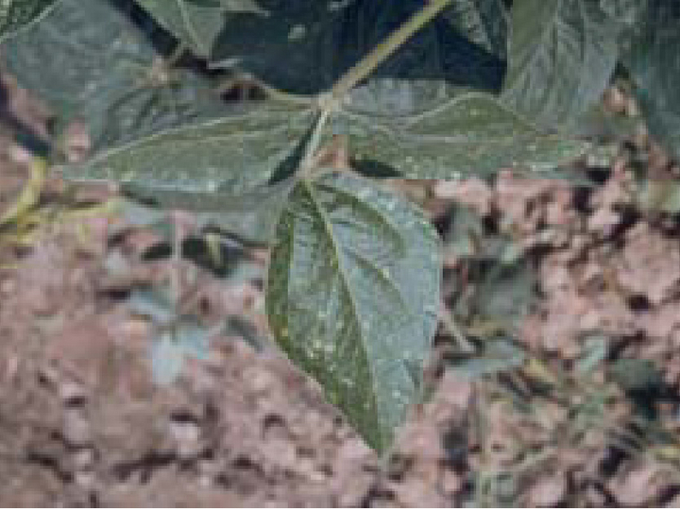

Symptome
auf
der
Blattoberseite

On
the
upper
sides
of
the
leaves,
small,
light
to
light
yellow
spots
can
be
seen
at
first,
which
are
between
2
and
8
mm
in
size.
The
spots
enlarge,
are
irregular
in
shape
and
size,
and
eventually
merge.
The
infested
leaves
wilt
and
die.
On
the
undersides
of
the
leaves,
a
grayish-purple
sporangia
can
be
seen
on
the
dead
tissue.

Pods
can
also
be
infested,
but
no
symptoms
can
be
seen
on
them
externally.
On
seeds
within
pods,
downy
mildew
develops
on
the
seed
surface
and
forms
a
milky
white
crust
consisting
of
the
surviving
spores
(oospores).
Plants
that
grow
from
infected
seeds
remain
small,
are
stunted,
and
soon
die.

**Host
plants**

The
host
plant
is
exclusively
the
soybean.

**Distribution**

*Peronospora
manshurica*
is
distributed
worldwide.

**Propagation
and
transmission**

The
pathogen
is
usually
transmitted
with
the
seed,
but
can
also
survive
on
infected
plant
residues
in
the
soil
in
the
form
of
permanent
spores.
In
the
stand,
downy
mildew
is
spread
by
sporangia
spread
by
wind
and
water
droplets.

High
humidity
and
cooler
temperatures
promote
disease
development.

**Economic
importance**

Depending
on
the
soybean
variety,
yield
losses
can
be
as
high
as
20%.

**Prevention
and
control**

* Adherence
  to
  a
  crop
  rotation
  of
  at
  least
  three
  years
* Use
  of
  healthy
  seeds
* Deep
  bagging
  of
  crop
  residues

**Services**

[Plant
Health
Services](en/plant/plant-health/plant-health-information)