|  |  |
| --- | --- |
| Logo AGES | |
| Potato cyst nematodes | |
|  |  |
| 14.03.2025 18:28 Uhr | |

**Potato
cyst
nematodes**

**Globodera
rostochiensis,
G.
pallida**

Last
change:
23.10.2024

**Profile**

Potato
cyst
nematodes
are
the
most
economically
important
animal
pests
of
potatoes.
Infestation
with
potato
cyst
nematodes
results
in
poor
growth
and
stunted
plants.
*Globodera
rostochiensis*
and
*Globodera
pallida*
are
listed
as
[Union
quarantine
pests](https://www.pflanzenschutzdienst.at/geregelte-schaedlinge/)
and
are
thus
subject
to
legal
regulations
to
prevent
their
introduction
and
spread
into
or
within
the
member
states
of
the
EU.

**Appearance**

Potato
cyst
nematodes
are
microscopic
nematodes
that
live
in
the
soil
and
parasitize
the
roots.
The
larvae
of
the
second
larval
stage
are
colorless
and
transparent
and
about
0.5
mm
long.
They
possess
a
strong
oral
spine.
Cysts
average
0.5
to
0.8
mm
in
size
and
are
round.
Immature
cysts
are
white/yellowish
while
mature
cysts
are
brown
in
color.

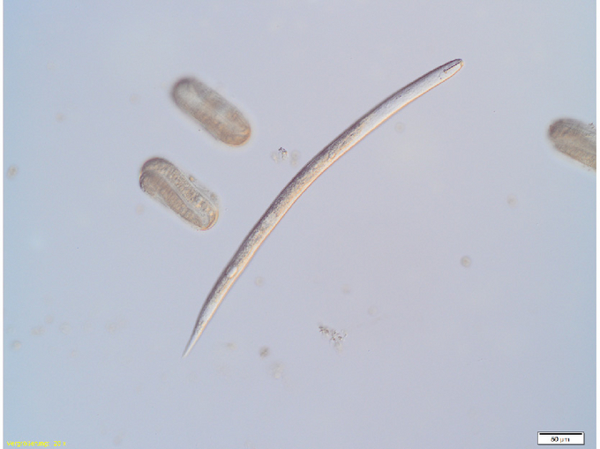

Eier
und
Larven
der
Kartoffelzystennematoden

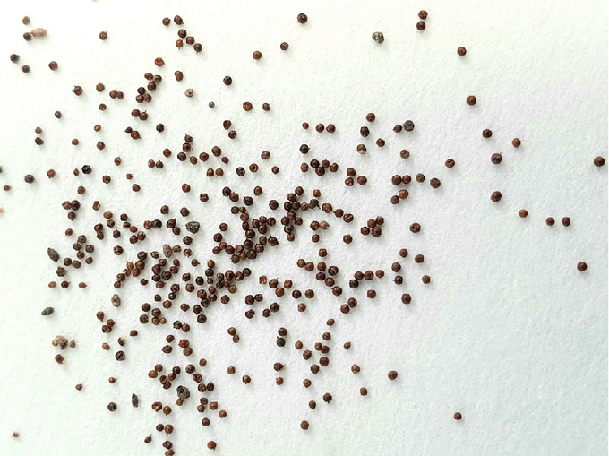

Zysten
der
Kartoffelzystennematoden

**Biology**

Potato
cyst
nematodes
are
two
species
of
nematodes
(Nematoda)
from
the
family
Heteroderidae:
yellow
potato
cyst
nematode*(Globodera
rostochiensis*)
and
white
potato
cyst
nematode*(Globodera
pallida*).
Each
species
in
turn
produces
different
pathotypes
or
virulence
groups.

The
developmental
cycle
of
potato
cyst
nematodes
occurs
through
the
egg
stage,
the
worm-like
larval
stages
(L1-L4),
to
the
sexually
mature
animals
in
about
eight
weeks.

The
larvae
survive
protected
in
cysts
in
the
soil.
Only
when
they
are
attracted
by
certain
substances
in
the
root
exudates
of
the
potato
root
do
they
leave
(2nd
larval
stage)
the
cyst
or
hatch
(from
about
March).
Then
they
penetrate
the
root
and
affect
root
growth
by
their
sucking
activity.
Through
several
molts,
they
develop
into
females
and
males
through
the
third
and
fourth
larval
stages.
The
females
swell
into
spherical
structures
and
burst
out
of
the
root
tissue
with
their
posterior
body
section.
The
motile,
worm-like
males
migrate
out
of
the
root
and
fertilize
the
females.
The
eggs
produced
by
the
females
(up
to
300
or
more)
remain
inside
the
body,
after
which
the
female
dies.
The
outer
skin
transforms
into
a
solid
brown
shell
(cyst)
and
falls
off
the
root.
These
cysts
survive
viable
in
the
soil
for
years
(up
to
20
years).
There
is
one
generation
per
year.

**Damage
symptoms**

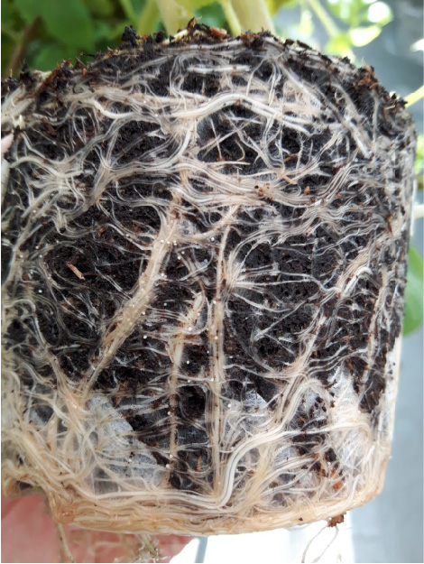

Zysten
an
den
Wurzeln

A
first
symptom
of
a
more
severe
nematode
infestation
is
poor
emergence
of
the
potatoes.
Infested
plants
are
retarded
in
growth,
yellowing
and
stunting.
The
damage
usually
occurs
in
nests
in
the
field
or
in
the
direction
of
cultivation.

In
cases
of
minor
or
late
infestation,
above-ground
symptoms
are
often
not
pronounced.
About
ten
weeks
after
potatoes
are
laid,
very
small,
spherical
cysts
on
the
roots
may
be
visible
to
the
naked
eye.

**Host
plants**

Potatoes*(Solanum
tuberosum*)
are
the
most
important
host
plants
of
potato
cyst
nematodes.
However,
tomatoes,
eggplant
and
other
members
of
the
Solanum
genus
from
the
Solanaceae
family
can
also
be
used
as
hosts.

**Distribution**

The
potato
cyst
nematodes
originated
in
South
America
and
probably
reached
Europe
with
potatoes
in
the
mid-19th
century.
From
Europe,
they
spread
to
other
areas
with
the
seed
potatoes.
Today,
there
is
a
worldwide
distribution,
from
the
temperate
climate
zone
to
sea
level
and
in
the
tropics
in
the
higher
regions,
practically
everywhere
where
potatoes
are
grown.

**Propagation
and
transmission**

*Globodera
rostochiensis*
and
*G.
pallida*
are
spread
by
passive
transport.
Soil
from
contaminated
fields
containing
cysts
or
infested
potatoes
and
soil
adhering
to
processing
equipment
(e.g.,
on
farm
machinery)
contribute
to
spread.
Consideration
should
also
be
given
to
the
transport
of
cysts
by
wind
and
water
from
unremediated
areas,
as
well
as
spread
by
common
harvesting
machinery,
etc.

**Economic
importance**

Potato
cyst
nematodes
are
widespread
worldwide
and
can
cause
yield
losses
of
30%-80%.

**Prevention
and
control**

Potato
cyst
nematodes
are
difficult
to
control
due
to
their
resistant
cysts.
Remediation
of
infested
areas
is
only
possible
in
the
long
term.
Successful
sanitation
requires
collaborative
action
and
measures
in
the
affected
growing
areas.

**Preventive
measures**

* Use
  only
  officially
  approved
  planting
  material
  that
  has
  been
  checked
  for
  freedom
  from
  infestation
  by
  nematodes
  in
  accordance
  with
  phytosanitary
  regulations.
* Timely
  detection
  of
  infestation
  by
  soil
  testing
  for
  potato
  cyst
  nematodes
  one
  year
  before
  planned
  cultivation
  (mandatory
  for
  seed
  potato
  cultivation).
* Farm
  hygiene:
  in
  case
  of
  nematode
  infestation
  on
  the
  farm,
  cleaning
  of
  cultivation
  equipment,
  footwear
  and
  vehicles
  is
  of
  great
  importance
  to
  prevent
  spreading
  of
  the
  cysts
  with
  soil
  to
  further
  areas.
  Waste
  soil
  from
  sorting
  should
  never
  be
  spread
  on
  arable
  land
  or
  on
  the
  manure
  heap
  (risk
  of
  nematode
  spread
  with
  manure
  spreading).
* Crop
  rotation:
  Potato
  cyst
  nematodes
  are
  typical
  crop
  rotation
  pests,
  therefore
  a
  wide
  crop
  rotation
  reduces
  the
  risk
  of
  infestation
  or
  the
  infestation
  density
  of
  the
  nematodes
  (e.g.
  potatoes
  at
  most
  every
  four
  years
  on
  the
  same
  area).
  The
  most
  effective
  control
  is
  consistent
  suspension
  of
  potato
  cultivation
  for
  a
  period
  of
  15
  -
  20
  years.
* Weed
  control:
  potatoes
  growing
  through
  the
  soil
  provide
  ideal
  propagation
  opportunities
  for
  potato
  cyst
  nematodes;
  after
  harvest,
  potatoes
  left
  lying
  on
  the
  ground
  should
  be
  removed
  or
  brought
  to
  the
  surface
  to
  freeze
  out.
* Weed
  control:
  various
  wild
  plants
  of
  the
  nightshade
  family
  contribute
  as
  host
  plants
  to
  further
  propagation
  of
  potato
  cyst
  nematodes.

**Cultivation
of
nematode-resistant
potato
varieties**

* Selective
  cultivation
  of
  nematode-resistant
  potato
  varieties
  prevents
  severe
  infestation
  increase
  and
  nematode
  density
  can
  be
  reduced
  up
  to
  88%
  after
  one
  year
  of
  cultivation
  and
  up
  to
  99%
  after
  three
  years
  of
  cultivation.
* Nematode-infested
  areas
  can
  be
  rehabilitated
  in
  the
  long
  term
  with
  the
  cultivation
  of
  nematode-resistant
  varieties
  in
  consumer
  crops.
* According
  to
  the
  EU
  Directive
  and
  the
  regulations
  of
  the
  German
  states,
  only
  consumption
  potatoes
  with
  corresponding
  nematode
  resistance
  may
  be
  grown
  on
  nematode-infested
  areas.
* The
  pathotype
  present
  in
  the
  field
  can
  be
  determined
  by
  means
  of
  a
  pathotype
  test
  (biotest).
  (Pathotypes
  or
  virulence
  groups:
  Ro1,
  Ro2/3,
  Ro4,
  Ro5,
  Pa1,
  Pa2/3).
* Nematode-resistant
  varieties
  can
  also
  be
  used
  preventively
  on
  nematode-free
  fields.
  Crop
  rotation
  should
  continue
  to
  be
  followed
  to
  avoid
  selecting
  resistance
  breakers.

**Phytosanitary
status**

Yellow
potato
cyst
nematode*(Globodera
rostochiensis*)
and
white
potato
cyst
nematode*(Globodera
pallida*)
are
listed
as
[Union
quarantine
pests](https://www.pflanzenschutzdienst.at/geregelte-schaedlinge/)
and
are
thus
subject
to
legal
regulations
to
prevent
their
introduction
and
spread
into
or
within
the
member
states
of
the
EU.

**Specialized
information**

**Sampling
-
potato
cyst
nematodes**

For
control
of
potato
cyst
nematodes,
official
sampling
or
sampling,
under
official
supervision
by
trained
personnel,
of
the
soil
of
the
growing
area
according
to
sampling
plan
is
necessary.

**Services**

[Plant
health
services
and
nematode
testing](en/plant/plant-health/plant-health-information)