|  |  |
| --- | --- |
| Logo AGES | |
| Peach fruit fly | |
|  |  |
| 31.03.2025 02:18 Uhr | |

**Peach
fruit
fly**

**Bactrocera
zonata**

Last
change:
28.10.2024

**Profile**

The
peach
fruit
fly
is
an
important
non-native
pest
of
fruit
of
many
different
fruit
and
vegetable
crops
and
is
one
of
the
priority
quarantine
pests
in
the
European
Union.
The
feeding
of
the
larvae
(maggots)
destroys
the
flesh
of
the
fruit
and
makes
it
inedible.

**Appearance**

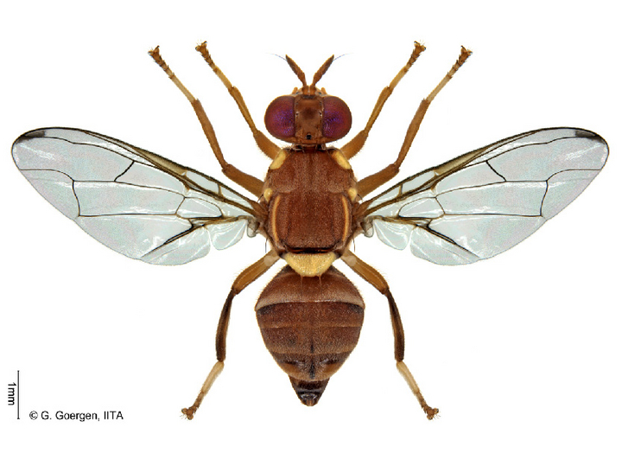

Adulte
Pfirsichfruchtfliege  
Die
Abbildung
der
Adulten
Pfirsichfruchtfliege
"Bactrocera
zonata
female"
von
G.
Goergen
IITA
ist
lizenziert
unter
CC
BY
4.0

The
peach
fruit
fly
belongs
to
the
fruit
fly
family
(Tephritidae).

The
adult
flies
are
about
5
mm
in
size
and
predominantly
orange
to
brownish
in
color.
They
have
a
yellow
dorsal
shield
and
have
a
dark
spot
in
the
wing
tip.

The
larvae
(maggots)
are
white
to
cream
colored,
up
to
1
cm
long
in
the
last
larval
stage,
and
have
a
black
mouth
hook.

**Biology**

Females
of
the
peach
fruit
fly
lay
eggs
under
the
skin
of
ripening
fruit.
After
a
few
days,
the
larvae
hatch
from
the
eggs
and
feed
on
the
flesh
of
the
fruit.
They
develop
inside
the
fruit,
but
leave
it
in
the
last
larval
stage
and
drop
to
the
ground.
In
the
soil
under
the
host
plant,
pupation
occurs
and
the
adults
hatch
from
the
pupae.
The
entire
development
cycle
is
temperature
dependent
and
lasts
several
weeks
under
optimal
conditions
(25
°C
-
30
°C).
The
adults
can
live
for
several
months
and
the
females
lay
several
hundred
eggs
during
this
time.

**Damage
symptoms**

Egg
laying
results
in
punctate
puncture
marks
on
infested
fruit.
The
larvae
feed
in
the
fruit
and
destroy
the
flesh.
This
can
lead
to
rotting
of
the
fruit.
Due
to
the
feeding
activity
of
the
larvae,
considerable
damage
can
occur
inside
the
fruit
even
before
symptoms
are
externally
visible.
In
the
early
stages
of
infestation,
symptoms
of
damage
are
difficult
to
see.
Peach
fruit
flies
attack
only
the
fruit,
so
there
is
no
damage
to
other
parts
of
the
plant,
such
as
leaves,
trunk,
branches
or
roots.

**Host
plants**

As
a
polyphagous
fruit
fly
(i.e.,
it
can
feed
on
many
different
plants),
the
peach
fruit
fly
has
a
large
number
of
potential
host
plants.
The
main
host
plants
are
guava*(Psidium
guajava*),
mango*(Mangifera
indica*),
and
peach*(Prunus
persica*).
In
addition
to
these
main
host
plants,
a
total
of
over
50
secondary
hosts
are
known
which
can
be
used
alternatively
for
development.
These
include
important
native
cultivated
plants
such
as
apricot*(Prunus
armeniaca*),
apple*(Malus
domestica*)
or
pear*(Pyrus*
spp.).

**Distribution**

The
peach
fruit
fly
originates
from
Asia
(e.g.
India,
Bangladesh,
Thailand,
Pakistan),
and
has
been
present
in
the
Arabian
Peninsula
since
the
1980s
and
in
northern
Africa
(e.g.
Egypt,
Libya)
since
the
1990s.
It
has
been
able
to
re-establish
itself
in
some
countries
(e.g.
Egypt),
but
in
others
it
has
also
been
eradicated,
at
least
temporarily
(e.g.
Israel,
USA).
In
Austria,
individual
specimens
of
the
peach
fruit
fly
have
been
found
in
recent
years,
although
this
is
not
an
established
population.
In
this
country,
establishment
of
the
peach
fruit
fly
can
be
ruled
out
due
to
winter
conditions.
Established
populations
are
also
not
known
from
other
countries
of
the
European
Union
so
far.

**Propagation
and
transmission**

The
spread
of
the
peach
fruit
fly
can
be
active
or
passive.
Carryover
by
means
of
infested
fruit
(commercial
goods,
luggage
of
travelers)
to
previously
uninfested
areas
is
considered
the
most
important
mode
of
spread.
In
addition,
passive
spread
can
also
occur
by
wind
dispersal.
Active
dispersal
occurs
by
the
flight
of
adults
up
to
25
km.

**Economic
importance**

The
peach
fruit
fly
is
one
of
the
world's
most
important
damaging
fruit
fly
species
and,
once
introduced,
can
potentially
cause
extensive
damage
to
the
fruit
of
host
plants.

**Prevention
and
control**

* To
  detect
  the
  occurrence
  (monitoring)
  of
  the
  peach
  fruit
  fly:
  Attach
  suitable
  fruit
  fly
  traps
  (e.g.
  Delta
  traps,
  McPhail
  traps,
  ...)
  to
  catch
  the
  adults
  using
  specific
  attractants:
  + Parapheromone
    (methyl
    eugenol)
    to
    attract
    males
  + protein-based,
    to
    attract
    female
    flies
* There
  are
  currently
  no
  plant
  protection
  products
  authorised
  against
  this
  pest
  in
  Austria
  (see
  [list
  of
  plant
  protection
  products
  authorised
  in
  Austria](https://www.baes.gv.at/zulassung/pflanzenschutzmittel/pflanzenschutzmittelregister/))

**Phytosanitary
status**

Non-European
fruit
flies
(Tephritidae)
such
as
the
peach
fruit
fly
are
listed
as
[Union
quarantine
pests](https://www.pflanzenschutzdienst.at/geregelte-schaedlinge/)
of
the
European
Union
and
are
thus
subject
to
legal
regulations
to
prevent
their
introduction
and
spread
into
or
within
the
member
states
of
the
EU.
Please
observe
the
obligation
to
notify
in
case
of
an
occurrence
and
contact
the
[official
plant
protection
service
of](https://www.pflanzenschutzdienst.at/kontakte-bundeslaender/)
your
federal
state.

**Specialist
information**

**Research**

Since
2012,
we
and
the
official
plant
protection
services
of
the
federal
states
have
been
continuously
monitoring
the
occurrence
of
the
peach
fruit
fly
and
other
important
fruit
fly
species
in
Austria.

We
are
also
involved
in
various
European
and
international
co-operations
and
projects
on
fruit
flies

[EUPHRESCO
network
project
FLY
DETECT](https://drop.euphresco.net/data/a6af73b6-4018-4b2f-910a-25bf4a23ee0e)

[H2020
project:
FF-IPM
-
Fruit
Flies
In-silico
/
Prevention
&
Management](https://fruitflies-ipm.eu/)

**Publications**

Milonas,
P.,
Egartner,
A.,
Ivanova,
I.,
2020.
Development
and
implementation
of
early
detection
tools
and
effective
management
strategies
for
invasive
non-European
and
other
selected
fruit
fly
species
of
economic
importance
(FLY
DETECT).
Zenodo.
[doi](http://doi).
[org/10.5281/zenodo.3732297](https://zenodo.org/record/3732297#.YaiqPecxlPY)

Egartner,
A.,
Lethmayer,
C.,
Gottsberger,
R.
A.,
Blümel,
S.,
2019.
Survey
on
Bactrocera
spp.
(Tephritidae,
Diptera)
in
Austria.
Bulletin
OEPP/EPPO
Bulletin
49(3).
[doi](https://doi).
[org/10.1111/epp.12604](https://onlinelibrary.wiley.com/doi/10.1111/epp.12604)

Lethmayer,
C.,
Egartner,
A.,
2019.
Invasive
flies
in
domestic
fruit
production.
Better
fruit
8,
7-8.

Lethmayer,
C.,
2011.
Dangerous
flies
for
apples
&
co.
Better
Fruit
12,
4-5.

**Links**

[Information
from
the
EPPO
on
the
peach
fruit
fly](https://gd.eppo.int/taxon/DACUZO)

[National
reference
laboratory
for
insects
and
mites](en/ages/reference-centres-laboratories/national-reference-laboratory-for-plant-health-insects-and-mites)

[European
Reference
Laboratory
for
Plant
Health
-
Insects
and
Mites](en/ages/reference-centres-laboratories/european-reference-laboratory-for-plant-health-insects-and-mites)

**Services**

[Plant
Health
Services](en/plant/plant-health/plant-health-information)