|  |  |
| --- | --- |
| Logo AGES | |
| Kamtschatka-Beifuß | |
|  |  |
| 06.10.2024 19:21 Uhr | |

**Kamtschatka-Beifuß**

Last
change:
01.02.2024

**Profile**

Kamchatka
mugwort
can
form
very
dense
stands
and
invade
and
cause
problems
in
agricultural
and
horticultural
crops.

**Appearance**

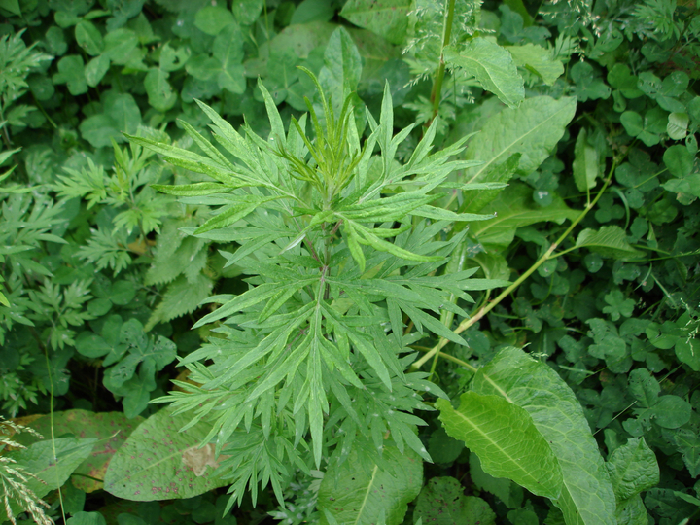

Habitus
und
Blätter
des
Kamtschatka-Beifuß

Kamchatka
mugwort
strongly
resembles
the
native
common
mugwort*(Artemisia
vulgaris*).
However,
there
are
distinguishing
characteristics.
Kamchatka
mugwort
is
a
perennial
plant
that
grows
up
to
150
cm
tall
and
forms
long
stolons.
The
stems
are
reddish
and
hardly
branched,
and
therefore
the
species
often
occurs
"in
troops".
A
distinctive
feature
is
that
the
species
is
strongly
aromatic
(camphor
smell)
and
blooms
very
late
in
the
year,
only
from
October.

**Distribution**

Kamchatka
mugwort
originates
from
East
Asia
most
probably
from
southeast
China.
In
Austria
the
species
was
described
for
the
first
time
at
the
end
of
the
middle
of
the
20th
century.
The
species
is
considered
naturalized
in
our
country
and
is
now
widespread,
especially
in
northern
Tyrol,
Salzburg,
and
Upper
Austria.
There
are
further
occurrences
in
and
around
Vienna
and
in
the
Klagenfurt
basin.
The
warmth-loving
species
is
spreading,
as
evidenced
by
the
increase
in
finds
in
recent
years.
Modeling
has
also
shown
that
the
species
will
benefit
greatly
from
climate
change
and
that
the
climatically
favorable
areas
in
Austria
will
increase
significantly.
The
plant
mainly
colonizes
roadsides,
ruderal
areas
(e.g.
gravel
pits),
riparian
areas
and
vineyards.

**Propagation**

The
spread
of
the
plants
is
vegetative
by
runners
and
so
the
plant
can
cover
a
large
area
in
a
short
time.
The
species
blooms
in
our
country
very
late
in
the
year
(from
October)
and
therefore
forms
seeds
only
in
exceptional
cases.
The
spread
mainly
takes
place
through
a
spread
of
root
parts
or
rhizomes,
with
the
help
of
contaminated
root
balls
of
garden
and
ornamental
plants,
from
agricultural
machinery
or
through
floods
along
rivers.

**Economic
significance**

Due
to
its
dense
populations
and
competitive
effect,
Kamchatka
mugwort
can
suppress
agricultural
and
horticultural
crops
and
cause
problems
(yield
losses).
So
far,
the
species
has
only
been
found
sporadically
in
fields
(Tyrol,
Upper
Austria).
The
edges
of
fields
are
frequently
affected,
but
there
are
also
observations
that
the
species
can
occur
en
masse
in
crop
stands.

[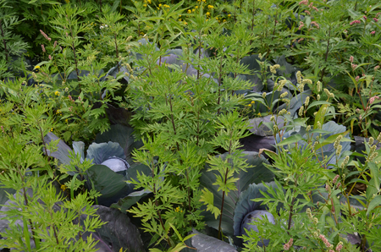](download/sdl-eyJ0eXAiOiJKV1QiLCJhbGciOiJIUzI1NiJ9.eyJpYXQiOjE2MDk0NTkyMDAsImV4cCI6NDA3MDkwODgwMCwidXNlciI6MCwiZ3JvdXBzIjpbMCwtMV0sImZpbGUiOiJmaWxlYWRtaW4vX3Byb2Nlc3NlZF8vNi9mL2NzbV9LYW10c2NoYXRrYS1CZWlmdXNzXzFfYWU4NDdhYzJkMC5qcGciLCJwYWdlIjoyNTM3fQ.z0S7T4gTKqvXnSU7FQECNdtXBtgY-zFYtXIUHoM8PD0/csm_Kamtschatka-Beifuss_1_ae847ac2d0.jpg)

Kamchatka
mugwort
in
red
cabbage.

[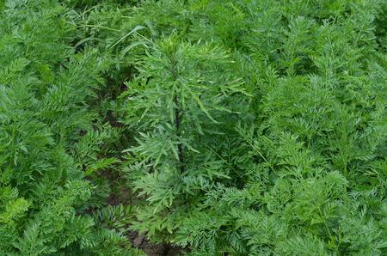](download/sdl-eyJ0eXAiOiJKV1QiLCJhbGciOiJIUzI1NiJ9.eyJpYXQiOjE2MDk0NTkyMDAsImV4cCI6NDA3MDkwODgwMCwidXNlciI6MCwiZ3JvdXBzIjpbMCwtMV0sImZpbGUiOiJmaWxlYWRtaW4vX3Byb2Nlc3NlZF8vOS9mL2NzbV9LYW10c2NoYXRrYS1CZWlmdXNzXzJfMDI3ODIyMDJmYi5qcGciLCJwYWdlIjoyNTM3fQ.WBdnbnHwypv2FxSoDwF-vllBRZTNl1osz0zkj72RrcQ/csm_Kamtschatka-Beifuss_2_02782202fb.jpg)

Kamchatka
mugwort
in
carrots.

[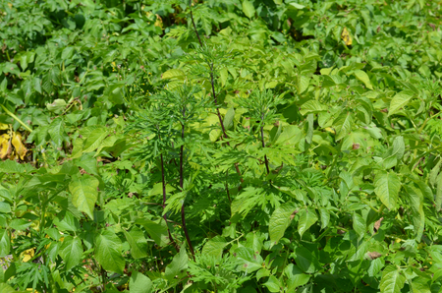](download/sdl-eyJ0eXAiOiJKV1QiLCJhbGciOiJIUzI1NiJ9.eyJpYXQiOjE2MDk0NTkyMDAsImV4cCI6NDA3MDkwODgwMCwidXNlciI6MCwiZ3JvdXBzIjpbMCwtMV0sImZpbGUiOiJmaWxlYWRtaW4vX3Byb2Nlc3NlZF8vMy9lL2NzbV9LYW10c2NoYXRrYS1CZWlmdXNzXzNfOTg3YTQyN2M0Yi5qcGciLCJwYWdlIjoyNTM3fQ.xT1epLz0OTwtKcDhG3VrytsCfHWg9qneSfVl10_BKYE/csm_Kamtschatka-Beifuss_3_987a427c4b.jpg)

The
Kamchatka
mugwort
in
potato.

**Prevention
and
control**

* Early
  detection
  and
  targeted
  measures
  to
  control
  first
  nests
  are
  extremely
  important
  to
  prevent
  establishment
  and
  spread
  on
  the
  arable
  land
  (uprooting,
  mowing).
* Avoid
  carryover
  of
  root
  pieces
  at
  all
  costs.

**Specialist
information**

Follak
S.
(2023):
Kamchatka
mugwort
-
one
more
problem
weed?
Der
Pflanzenarzt
76(9-10),
pp.
24-25.

**Services**

[Pflanzengesundheit
Services](en/plant/plant-health/plant-health-information)