|  |  |
| --- | --- |
| Logo AGES | |
| Common cocklebur | |
|  |  |
| 31.10.2024 11:00 Uhr | |

**Common
cocklebur**

**Xanthium
strumarium
agg.**

Last
change:
10.09.2024

**Profile**

Common
burdock
is
an
annual
plant
of
the
composite
family.
It
is
an
important
weed
in
many
summer
crops.
The
species
is
very
rich
in
form
and
occurs
in
Central
Europe
with
individual
clades
(or
subspecies)
that
are
probably
native,
while
other
clades
are
classified
as
naturalized
(native
to
North
America).

**Appearance**

The
cotyledons
are
stalked,
narrowed
at
both
ends,
acuminate
and
pinnately
lobed.
The
leaves
are
alternate,
also
stalked
and
slightly
lobed.
The
leaf
base
is
wedge-
to
heart-shaped,
depending
on
development.
On
the
branches
of
the
shoots
there
are
often
dotted
or
dash-like
drawings,
some
clans
are
without
or
only
with
indistinct
drawings.
Flowering
time
is
usually
in
August,
shortly
after
which
the
roundish-elongated
fruit
heads
are
formed,
which
are
covered
with
sheathing
spines.
Depending
on
the
clan,
only
a
few
to
all
of
these
spines
have
different
hooked
curvatures.
The
number
of
heads
formed
per
plant
varies
greatly
(about
80-400)
depending
on
the
size
and
degree
of
branching
of
the
plant
and
the
prevailing
site
conditions.

**Distribution**

Occurrences
of
common
burdock
in
agriculture
have
been
known
from
the
Pannonian
since
the
1970s.
In
the
early
1990s,
occurrences
were
described
in
maize
near
Bruck
an
der
Leitha
on
heavy
and
moist
soils.
Currently,
in
addition
to
occurrences
in
Burgenland
and
eastern
Lower
Austria,
there
are
also
larger
populations
in
Styria
in
the
districts
of
Leibnitz
and
southeastern
Styria.
Particularly
affected
by
common
burdock
are
root
crops
such
as
corn,
soybean,
oil
pumpkin
and
sunflower.

**Spread**

The
burdock-like
fruit
heads
are
adapted
to
animal
dispersal
(these
also
adhere
to
clothing
and
shoes!).
In
addition,
the
fruit
heads
are
buoyant
(up
to
30
days)
and
can
also
be
spread
by
tillage
and
harvesting
operations
in
the
field
and
over
longer
distances.
Spread
of
the
fruit
heads
via
soil
material
(excavation)
is
also
possible.

**Economic
importance**

Common
burdock
is
a
competitive
weed.
The
species
is
able
to
adapt
very
plastically
in
height
and
branching
to
its
competitors
and
site
conditions.
The
height
ranges
from
50
to
150
cm
and
therefore
the
common
lard
burdock
can
overgrow
and
suppress
the
cultivated
plants.
Even
a
few
xanthium
plants
per
square
meter
can
reduce
yield.
Competition
trials
have
shown
that
yield
loss
at
5
plants/m2
was
62%
in
corn
and
56%
in
sunflower,
with
competition
occurring
throughout
the
growing
season.

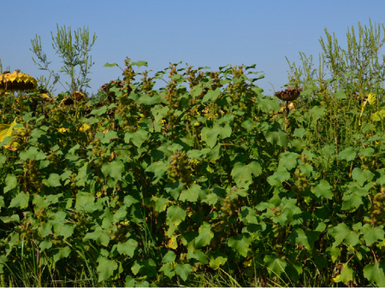

Gewöhnliche
Spitzklette
in
einem
Sonnenblumenfeld

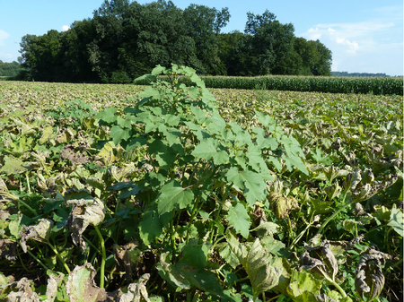

Gewöhnliche
Spitzklette
in
einem
Ölkürbisfeld

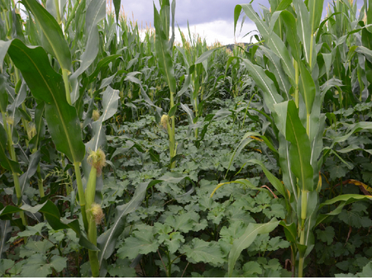

Gewöhnliche
Spitzklette
in
einem
Maisfeld

**Prevention
and
control**

* Individual
  plants
  or
  smaller
  populations
  should
  be
  pulled
  out
  before
  flowering
  or
  seed
  formation.
* In
  corn,
  triketones
  or
  triketone-containing
  herbicide
  combinations,
  among
  others,
  work
  well
  against
  common
  limpet,
  while
  in
  soybean
  the
  active
  ingredient
  imazamox
  provides
  control
  (see
  for
  other
  active
  ingredients
  and
  crops:
  [List
  of
  plant
  protection
  products
  approved
  in
  Austria](https://www.baes.gv.at/zulassung/pflanzenschutzmittel/pflanzenschutzmittelregister/)).

**Services**

[Plant
Health
Services](en/plant/plant-health/plant-health-information)