|  |  |
| --- | --- |
| Logo AGES | |
| Citrus flatid planthopper | |
|  |  |
| 22.01.2025 09:01 Uhr | |

**Citrus
flatid
planthopper**

**Metcalfa
pruinosa**

Last
change:
21.08.2024

**Profile**

The
blue
cicada
is
an
invasive
species
and
sucks
plant
sap
from
many
different
host
plants.
This
can
affect
plant
growth
and
fruit
formation.
In
addition,
bluebottle
cicadas
produce
a
lot
of
honeydew.

**Appearance**

The
adult
reaches
a
length
of
about
8
mm
including
wings.
Its
basic
color
is
gray-blue,
which
is
the
origin
of
its
German
name.
The
wings
are
partially
covered
with
white
wax
flakes.

The
larvae
are
whitish
to
pale
green
and
are
encased
in
conspicuous
white
wax
filaments.

The
eggs
are
elongated
oval
and
measure
about
0.8
mm.

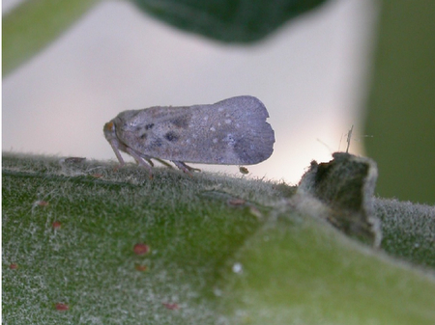

Bläulingszikade

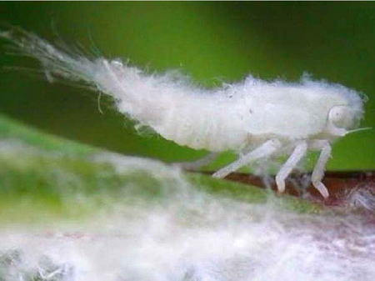

Larve
der
Bläulingszikade

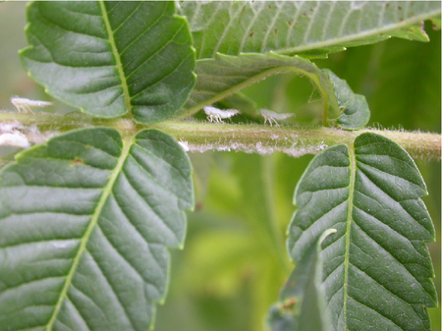

Larven
der
Bläulingszikade
auf
Essigbaum

**Biology**

The
blue
cicada
belongs
to
the
butterfly
cicada
family.
To
feed,
the
animal
stings
the
host
plants
with
its
proboscis
and
sucks
up
the
sugary
plant
sap
transported
in
it.
Excess
sugar
sap
is
excreted
as
honeydew.

Adult
cicadas
fly
from
August
to
late
fall
and
lay
their
eggs
in
soft
cork
or
cork
pores
(lenticels)
of
twigs,
branches,
or
trunks.
The
eggs
partially
protrude
into
the
open
air.
After
overwintering,
larvae
hatch
from
them
beginning
in
late
May.
These
larvae
can
jump
excellently.
Like
the
adult
cicadas,
they
feed
by
sucking
plant
juices.
In
the
course
of
their
development,
they
pass
through
five
larval
stages
-
in
the
last
two,
external
wing
systems
are
already
visible.
From
about
mid-July,
the
adult,
flight-capable
cicadas
emerge.
The
blue
cicada
is
not
a
vector
of
viruses
and
phytoplasmas.

**Damage
symptoms**

As
a
result
of
the
sucking
activity,
plant
growth
and
the
formation
of
fruits
can
be
impaired.
The
production
of
honeydew
with
black
fungi
(sooty
mold)
settling
on
it
contaminates
the
host
plants
and
their
fruits,
thus
reducing
their
quality.
On
ornamental
woody
plants,
shedding
remains
of
larvae
and
waxy
wool
lead
to
visual
impairment.

Beekeepers
are
very
fond
of
blue
cicadas,
as
a
lot
of
honeydew
is
produced
in
late
summer
when
there
is
a
high
incidence
of
cicadas,
which
is
excellent
bee
food
during
this
period
when
there
are
few
bees.

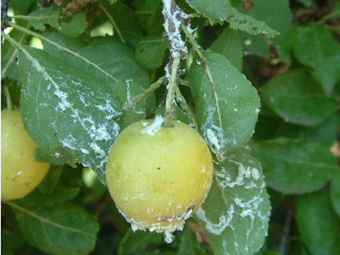

Befall
der
Bläulingszikade
an
Kriecherl

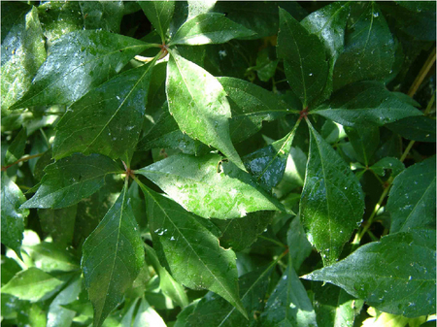

Honigtau
an
Wildem
Wein

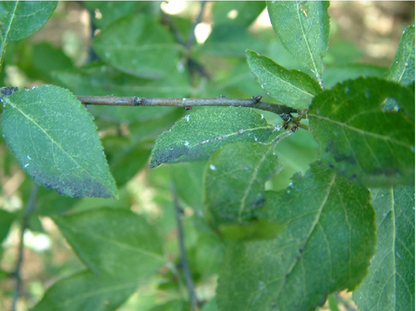

Russtaupilze
auf
Honigtauausscheidungen
der
Bläulingszikade

**Host
plants**

The
blue
cicada
has
a
wide
host
plant
range.
Mainly
it
sucks
on
woody
plants,
more
rarely
also
on
herbaceous
plants.
In
Austria
it
has
been
found
on
290
plant
species
so
far.
Some
examples
of
strongly
affected
plants
are:

* Maple*(Acer*
  sp.)
* Apple*(Malus*
  sp.)
* Stinging
  nettle*(Urtica
  dioica*)
* Blackberry*(Rubus
  fruticosus*)
* Tree
  of
  gods*(Ailanthus
  altissima*)
* Dogwood*(Cornus*
  sp.)
* Raspberry*(Rubus
  idaeus*)
* Elderberry*(Sambucus
  nigra*)
* *Hydrangea
  (Hydrangea*
  sp.)
* Apricot*(Prunus
  armeniaca*)
* Peach*(Prunus
  persica*)
* Currant*(Ribes*
  sp.)
* Black
  locust
  (Robinia*pseudacacia*)
* Bush
  marshmallow*(Hibiscus
  syriacus*)
* Wood
  vine*(Clematis
  vitalba*)
* Vine*(Vitis
  vinifera*)
* Wild
  vine*(Parthenocissus
  quinequefolius*)

**Distribution**

The
blue
cicada
originates
from
North
America
and
was
first
found
in
Italy
within
Europe.
It
has
spread
to
Slovenia
and
Croatia.
Regionally,
it
occurs
in
France,
Switzerland,
Spain,
Hungary,
Serbia,
Montenegro,
Bulgaria,
Greece,
Turkey
and
Germany.
It
has
also
been
introduced
into
South
Korea.

In
Austria,
the
blue
cicada
was
first
found
in
Graz
(1996)
and
the
first
mass
occurrence
was
recorded
in
Vienna
in
2003.
Since
then,
the
range
of
the
blue
cicada
has
increased,
especially
in
the
east
of
Austria,
and
there
are
numerous
occurrences
in
Vienna,
Lower
Austria,
Burgenland
and
Styria.
Findings
of
the
blue
cicada
have
also
been
made
in
Klagenfurt.

**Propagation
and
transmission**

The
natural
spread
of
the
cicada
is
low,
but
there
is
a
risk
that
it
may
be
carried
unnoticed
by
human
activities.

**Economic
importance**

Economic
damage
can
occur
if
the
blue
cicada
occurs
in
masses
and
reduces
the
marketability
of
plants
or
fruits
due
to
its
wax
residues,
honeydew
or
sooty
mold.
No
damage
to
crops
has
yet
been
reported
in
Austria.

**Prevention
and
control**

* Avoidance
  of
  spreading:
  no
  transports
  of
  infested
  plants,
  or
  such
  plants
  that
  are
  or
  have
  been
  in
  the
  vicinity
  of
  heavily
  infested
  plants.
  The
  risk
  of
  unnoticed
  carryover
  is
  particularly
  high,
  as
  the
  eggs
  of
  the
  blue
  cicada
  are
  hidden
  in
  the
  bark
  cork.
* Cut
  back
  branches
  during
  the
  cold
  season,
  as
  overwintering
  eggs
  are
  found
  on
  them.
  However,
  eggs
  are
  also
  laid
  on
  older
  branches
  and
  stems
  that
  cannot
  be
  cut.
* Spray
  treatment
  with
  agents
  against
  sucking
  insects
  (wetting
  agent
  required),
  (see
  [list
  of
  plant
  protection
  products
  approved
  in
  Austria](https://www.baes.gv.at/zulassung/pflanzenschutzmittel/pflanzenschutzmittelregister/)).
* In
  southern
  European
  orchards
  and
  vineyards
  (Italy,
  France,
  Slovenia,
  Croatia),
  the
  blue
  cicada
  has
  been
  controlled
  very
  successfully
  in
  a
  biological
  way
  for
  several
  years:
  for
  this
  purpose,
  the
  parasitic
  cicada
  wasp
  Neodryinus
  typhlocybae,
  originating
  from
  North
  America,
  is
  released.
* In
  Vienna,
  a
  small
  population
  of
  the
  cicada
  wasp
  N.
  typhlocybae
  was
  released
  in
  2014
  for
  research
  purposes.
  Previously,
  its
  host
  range
  had
  been
  studied
  by
  us
  in
  relation
  to
  native
  cicada
  species.
  The
  results
  of
  this
  study
  clearly
  showed
  that
  this
  cicada
  wasp
  is
  very
  specialized
  on
  butterfly
  cicadas.
  From
  this
  group,
  however,
  only
  the
  blue
  cicada
  occurs
  in
  Austria.
  Therefore,
  there
  is
  no
  risk
  for
  native
  cicada
  species.

**Specialized
information**

**Publications**

Strauß,
G.,
2013.
[evaluation
of
potential
non-target
effects
of
Neodryinus
typhlocybae,
biocontrol
agent
of
Metcalfa
pruinosa,
for
Austria](https://iobc-wprs.org/publication-category/iobc-wprs-bulletins/2013).
IOBC-WPRS
Bulletin,
94,
87-88.

Strauß,
G.,
2012.
[environmental
risk
assessment
for
Neodryinus
typhlocybae,
biological
control
agent
against
Metcalfa
pruinosa,
for
Austria](https://ejes.cz/index.php/ejes/article/view/44).
European
Journal
of
Environmental
Sciences,
2(2),
102-109.

Kahrer,
A.,
Strauß,
G.,
Stolz,
M.,
Moosbeckhofer,
R.,
2009.
[observations
on
faunistics
and
biology
of
the
blue
cicada
(Metcalfa
pruinosa)
recently
introduced
to
Austria](https://www.zobodat.at/pdf/BEF_10_0017-0030.pdf).
Contributions
to
Entomofaunistics,
10,
17-30.

**Downloads**

**Services**

[Plant
Health
Services](en/plant/plant-health/plant-health-information)