|  |  |
| --- | --- |
| Logo AGES | |
| Bean seed fly | |
|  |  |
| 14.03.2025 14:36 Uhr | |

**Bean
seed
fly**

**Delia
platura
and
Delia
florilega**

Last
change:
06.02.2025

**Profile**

Seed
flies
occur
in
large
numbers
in
our
fields
every
year,
but
only
cause
damage
to
seedlings
of
heat-loving
crops
during
cool
weather.

**Appearance**

Seed
flies
resemble
houseflies,
are
gray
in
color
with
dark,
interrupted
stripes
on
the
dorsal
shield.
The
male
flies
-
recognizable
by
the
eyes
meeting
at
the
vertex
-
have
a
row
of
comb-like
bristles
on
the
splints
of
their
last
pair
of
legs
(=
hind
tibiae),
which
allows
them
to
be
distinguished
from
similar
species.

The
larvae
have
no
legs
and
the
head
capsule
is
recurved
so
that
the
anterior
end
is
pointed.
Inside,
mouthparts
("nail
hooks")
shine
through
in
black.
The
posterior
end
appears
as
if
cut
off
at
an
angle,
and
in
the
center
of
this
"oval"
lie
the
so-called
posterior
stigmas
(often
misinterpreted
as
eyes).
The
edge
is
occupied
by
about
15
small
papillae,
the
shape
of
which
can
be
used
for
species
identification.

The
eggs
are
white,
pencil-shaped
and
1
mm
in
size.

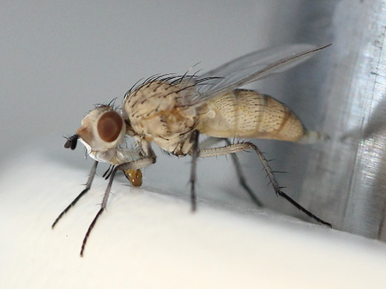

Saatenfliege

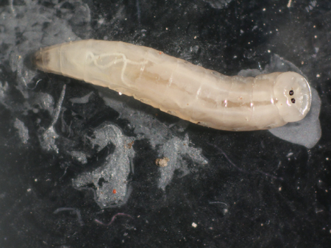

Larve
der
Saatenfliege

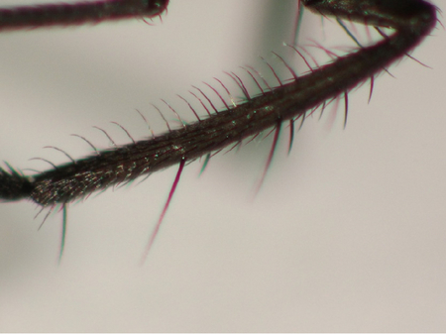

Borstiges
Hinterbein
des
Männchens

**Biology**

Seed
flies
belong
to
the
fly
family
of
flower
flies*(Anthomyiidae*)
and
are
assigned
to
the
genus
*Delia
sp.*
The
seed
flies
are
two
closely
related
species
with
similar
lifestyles,
namely
the
more
common
*Delia
platura*
and
the
rarer
*Delia
florilega*.
In
addition
to
the
name
seed
flies,
the
name
bean
seed
flies
is
also
common.

The
flies
are
flower
visitors
and
feed
exclusively
on
nectar.
The
flies
lay
their
1
mm
small,
pencil-shaped,
white
eggs
on
germinating
host
plants.
However,
there
are
also
known
cases
of
eggs
being
laid
on
bare
soil
during
ploughing.
The
flies
are
also
attracted
to
unrotted
plant
matter,
for
example
fields
fertilised
with
solid
manure
or
fields
after
grassland
or
intercropping
are
particularly
attractive
to
the
fly.

Fly
larvae
hatch
from
the
eggs
after
a
few
days.
The
larvae
feed
partly
on
bacteria,
which
multiply
strongly
under
unfavourable
germination
conditions
for
the
host
plants,
and
partly
they
actively
penetrate
plant
tissue,
which
in
turn
favours
bacterial
growth.
After
passing
through
three
larval
stages
(the
time
required
for
this
depends
on
the
temperature),
the
larvae
leave
their
host
plant
and
pupate
in
the
surrounding
soil
at
a
depth
of
a
few
centimetres.

After
a
short
pupal
period,
the
adult
flies
hatch
again,
completing
the
cycle.

In
this
way,
several
generations
of
the
fly
are
created,
while
damage
is
only
done
to
young
plants
in
spring.
Overwintering
finally
takes
place
as
a
puparium
(pupa)
in
the
soil.

**Damage
symptoms**

An
infestation
can
initially
be
recognised
externally
by
defects
in
the
rows
of
emerging
crops.
Germinating
host
plants
often
lag
behind
in
growth
and
show
eroded
roots,
holes
and
borings
in
the
root
collar,
stem
and
cotyledons.
Mining
tunnels
can
occur
in
bean
cotyledons,
and
the
stems
of
pumpkins
are
often
completely
hollowed
out,
in
which
large
numbers
of
fly
maggots
can
be
found.

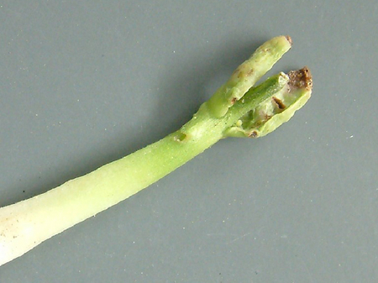

Miniergänge
in
den
Keimblättern

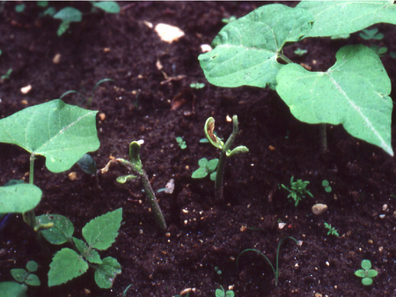

Fehlstellen
in
den
Reihen
auflaufender
Kulturpflanzen,
keimende
Wirtspflanzen
bleiben
zurück

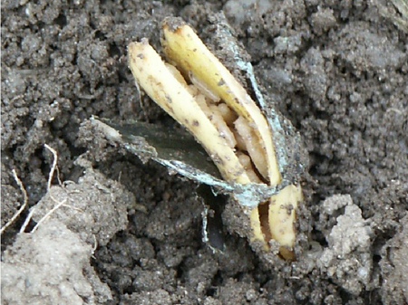

Der
Pflanzenstängel
ist
oft
völlig
ausgehöhlt
und
voller
Fliegenmaden

**Host
plants**

A
wide
variety
of
heat-loving
crops
such
as
maize,
soya,
spinach,
cucumber,
pumpkin,
beans,
melon,
courgette
and
asparagus
are
infested.
Under
suitable
conditions,
other
types
of
host
plants
may
also
be
infested.

**Distribution**

While
*Delia
platura*
is
worldwide
and
common
in
temperate
latitudes,
*Delia
florilega*
is
restricted
to
Central
Europe
and
Northern
Europe
and
is
also
found
less
frequently.

**Propagation
and
transmission**

Seed
fly
maggots
are
not
primary
plant
pests,
as
their
main
role
in
the
soil
is
to
break
down
organic
matter.
However,
since
rot-dwelling
microorganisms
develop
on
seedlings
under
unfavorable
germination
conditions,
these
also
provide
an
ideal
food
source
for
seed
fly
larvae.

**Economic
significance**

Economic
damage
to
germinating
plants
is
to
be
expected
from
the
1st
generation
of
larvae.

**Prevention
and
control**

In
general,
early
sowing
is
recommended
and
the
previous
year's
infestation
must
be
taken
into
account.

For
catch
crops,
plants
that
freeze
in
winter
should
be
selected.

Avoid
incorporating
poorly
rotted
plants
or
unripe
compost
into
the
soil
(especially
spinach).
If
incorporation
is
necessary,
it
should
be
carried
out
in
cool
weather
when
the
flies
are
not
active.

Do
not
apply
solid
manure
shortly
before
sowing
crops.

In
the
case
of
asparagus,
the
ridges
should
be
covered
with
plastic
sheeting.

Replant
infested
seedlings
(especially
common
with
cucumbers
and
pumpkins)

Plough
up
the
infested
crop
and
replant,
preferably
with
a
crop
that
does
not
require
heat
and
is
less
susceptible.

**Services**

[Plant
Health
Services](en/plant/plant-health/plant-health-information)